Account Team Transition: SOP

Prerequisites:
- An appropriate reason for handoff exists
  - Capacity shift
  - Internal org shift
  - The client requested a new team
- Avoid transitions during major milestones
  - Example: We should not transition an account in the middle of a launch
- The client is open to change (i.e. if the client has had issues with account transitions in the past, they may not be a candidate for a transition at this time)

Approval:
No accounts may transition without the approval of the Director of Delivery.

Process:

Assignee: Current Assigned Delivery Lead & Project Team
- Secure approval for transition(s) from the Director of Delivery
- Update all ClickUp data
  - All tasks should reflect scoped work that the client signed off on
  - Update statuses, assignees, descriptions, checklists, start/end dates, Gantt charts, estimated hours, logged time
  - Ensure tasks are truly Ready to Start
    - Detailed with context, resources, acceptance criteria, and comments with the latest work performed
  - BRAINS views are accurate and updated
  - Craft upcoming agendas
- Update all pertinent SFDC data + assets
  - Project assets (KO decks, training decks, UAT sheets, etc)
  - Project health
  - Project status
  - Estimated end date
  - Estimated hours difference
  - Dev work %
  - Ensure all hours toward the project are logged and accurate
- Complete the knowledge transfer worksheet
  - The outgoing team currently responsible for the project should complete
  - Add a document in CU to house the knowledge transfer worksheet (it should be separate from agendas)
  - Search for the Client KT Worksheet template in a new ClickUp doc to get started
- Schedule knowledge transfer sessions & assign/delegate workstreams
  - Depending on the size of the account and engagement, this could be anywhere from 1-3 sessions, but meeting time for an account transition should not exceed 2 hours (2h of meeting time, not logged time)
  - Limit attendees to the DLs, leading consultants and devs (if applicable)
  - The receiving DL should plan and communicate workstream assignments to respective members of their team
- Provide systems access to the new team
  - The existing DL/project team grants access and shares RPass logins to incoming teammate(s) for all relevant tools and systems
  - If the existing project team does not have permission to add new users, then they will communicate + coordinate with the client to grant access to new team member(s)
- Communicate changes to the customer
  - Current DL emails client to tee up changes, will discuss on next sprint call
  - Bring the assigned Account Manager and DoD to the call
  - DoD builds talk track for the explanation and shares with all parties in the client Slack channel before the call
  - DoD explains the reason for the change
  - DoD lays out the transition plan, ensures the client knows what to expect and that they feel comfortable with the changes, instills confidence in the client
  - Remind the client that their old team isn’t going anywhere; they still work at A8 (in most cases) and will be accessible by the incoming team
  - DL will follow up with an email recapping all changes and the transition plan
  - Account Manager will follow up in the coming 2-4 weeks to ensure the transition is going smoothly, will hop on sprint calls as needed
- 3-4 weeks to transition calls, deliverables, and allow for relationship-building
  - Outgoing DL and consultants are on the following 4 weekly sprint meetings
    - First 2 sprints: outgoing team pilots call, incoming team co-pilots call
    - Next 2 sprints: incoming team pilots call, outgoing team co-pilots call
  - After the 4th sprint meeting, the old team is entirely off calls, and the new team has full ownership by the end of week 4

Assignee: New Assigned Delivery Lead & Project Team
- Review the knowledge transfer worksheet before the knowledge transfer session
  - Receiving team to complete review and prepare questions for the upcoming KT session
- Review previous Avomas for sprint meetings and discovery workshops
- 3-4 weeks to transition calls, deliverables, and allow for relationship-building
  - The new DL and primary consultants are on the next 3-4 weekly meetings
    - Leads at least 1-2 of them, likely the latter 2, allowing the existing DL to run the first 1-2
  - By the 3rd or 4th call, the new project team should be running the call
  - Old team is completely off calls, new team has full ownership by the end of week 4

Assignee: Ops Team
- Update Front notifications so that the incoming team now sees all emails sent to the dedicated client inbox
- Ensure Client Slack Channel has new team members added. Old team members can remove themselves from the channel once transition is complete
- Update Billings/Recurring Billings with new Team assignment
- Update any NEXT retainer project information
- Update SF Project Fields
  - Project Team > new team
  - Project Lead > new Delivery Lead

Important Note:
Account shifts can be disruptive to the client, the work, and the internal team, so take your time to ensure seamless transition and handoff. Client relationship management is critical to our business, so it is pertinent that we dedicate time + care to ensure the transition is as smooth as possible, and that the client feels confident in the go-forward plan.
Once you make a transition, the project team structure needs to remain in place for a minimum of 2 months (retainers), or until the completion of the project
The knowledge transfer needs to be thorough - no exceptions.
It's frustrating for clients to have to repeat themselves or reshare assets, but more importantly, they're usually already coming from a place of stress/fear, so switching out project ownership and doing so sloppily could turn that fear into negative outcomes for all parties.

Knowledge Transfer Worksheet
This is to be completed by the existing assigned Delivery Lead and the project team.

We have a KT worksheet in ClickUp for you to use!

Create a new doc in the Agenda & Docs section of the project folder and apply the template Client KT Worksheet.
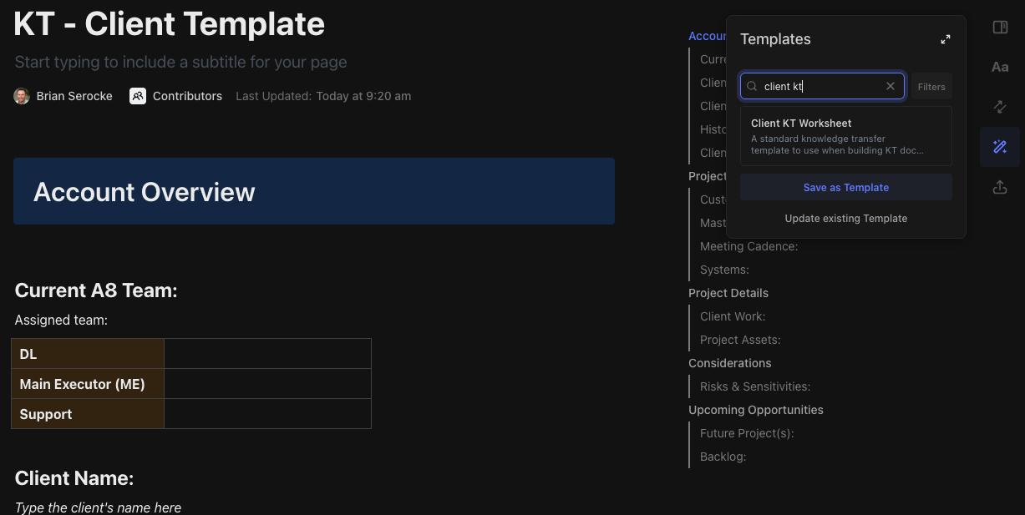

Below is an outline of generally what you should be including in your KT worksheet:

Old Team: including main executors and contributing developer(s)
New Team: including main executors and contributing developer(s)
Client Name: (link to account)
Client Project: (link to project in SF)
Project Brief: What is the master customer story? What are the overarching goals of the engagement?
History: What is the current status of the overall engagement? What are the key milestones we have achieved? Any major events, disruptions, issues, escalations? Meaningful check-ins with CX? Link to cases in SF
Client POCs: What contacts do we work with most often? What are they like? What are their titles? Who are their superiors?
Meeting Cadence: when is the weekly sprint scheduled? Are there any ad hoc meetings or discovery sessions planned?
Client Work: (link to CU views)
- Work in Review (CU view)
- Active Work (CU view)
- Issues and Blockers (CU view)
- Next Up (CU view)
- Schedule (CU view - gantt)
Project Assets: (link to project assets tab in SF - all assets should be added and updated)
- Internal KO Deck
- External KO Deck
- Process Diagram(s)
- ERD(s) / Data Model
- Key Documentation
- Training Deck(s)
- QA Sheet(s)
- UAT Sheet(s)
- Agendas, Notes, & Recaps (last 4 meetings)
- Ancillary assets in Google Drive (link to A8 client folder in the drive)
- Relevant Avomas
Risks & Sensitivities: Any verbiage or terminology to stay away from? Any present risks to the account or the client POCs or risks to the work?
Opportunities: Any opportunity for future work? Are additional projects coming down the pipe?

Proactive Client Churn: SOP

Prerequisites:
- An appropriate reason for proactive client churn exists
  - Attempt to create capacity
  - Toxic, negative, poor fit client, poor fit work items
- Client is not highly visible within HubSpot, not high risk
- Client is not in the middle of project work or other sensitive work that must be completed

Approval:
No accounts are to be churned proactively without the approval and alignment of the CXO, CEO, and DoD.
Process:

Assignee: Assigned Account Manager
- Discuss the proposed client churn account with the DoD and DL in the respective project review meeting. Explain the reason, rationale, and communication plan.
- Send an email to the client in question requesting time to meet with them and the CXO
- Build a client call plan to inform the talk track on the call with the customer; prepare for the call
- Hold call to discuss changes to the engagement, reason and rationale, and provide an offboarding plan. The offboarding plan should include finalization of documentation, handoff of all assets and artifacts, and introduction to a referral firm. We are also happy to provide 1 knowledge transfer session with the incoming firm.
- Create a cancelation ticket in HubSpot, process using the cancellation SOP, creating a billing adjustment case for our Ops Team to process final billings.
- Draft closeout deck
- Attend closeout meeting
- Send and email to the client’s HubSpot CSM to ensure they are aware what is going on

Assignee: Delivery Lead
- Finalize documentation
- Finalize close out deck
- Attend and lead close out meeting
- Cancel the project in Salesforce, fill out the cancellation reason

Assignee: Ops
- Process final billings

Project Team Member Departure

Types
- A8 consultant/PM electively left the organization
- A8 consultant/PM was exited from the organization
- A8 Delivery Lead electively left the organization
- A8 Delivery Lead was exited from the organization

Process - A8 Consultant/PM Left or Exited:

Assignee: Current Assigned Delivery Lead & Project Team
- Confirm with DoD timing for the departure and plan for the role
  - When is the consultant/PM’s last day of work?
  - Is the role being backfilled? When?
  - Is another existing team member stepping into the account in question?
- Complete the knowledge transfer worksheet
  - Transferring team to complete
  - Add a document in CU to house the knowledge transfer worksheet (should be separate from agendas)
- Schedule knowledge transfer session & assign/delegate workstreams
  - Depending on the size of the account and engagement this could be anywhere from 1-3 sessions, but meeting time for an account transition should not exceed 2 hours (2h of meeting time, not logged time)
  - Limit attendees to the DL, main executors and devs (if applicable)
- Provide systems access to new consultant (if they aren’t already in)
  - Existing delivery lead/project team grants access and shares RPass logins to incoming teammate(s) for all relevant tools and systems
  - If the existing project team does not have permission to add new users, then they will communicate + coordinate with client to grant access to new team member(s)
- Communicate changes to customer
  - Current DL emails client to tee up changes, will discuss on next sprint call
    - Add to agenda
  - Bring assigned Account Manager to the call
  - DL explains the reason for the change
  - DL lays out the transition plan, ensure the client knows what to expect and that they feel comfortable with the changes, instill confidence in the client
  - Remind client that the rest of their team isn’t going anywhere
  - DL to follow up with an email recapping all changes and the transition plan
  - Account Manager to follow up in the coming 2-4 weeks to ensure transition is going smoothly, will hop on sprint calls as needed

Assignee: New Consultant/PM
- Review knowledge transfer worksheet before the knowledge transfer session
  - Receiving team to complete review and prepare questions for the upcoming KT session
- Take over workstreams as quickly and comprehensively as possible

Process - A8 Delivery Lead Left or Exited:

Assignee: Incoming Delivery Lead/Interim Delivery Lead + Project Team
- Confirm with DoD timing for the departure and plan for the role
  - When is the DL’s last day of work?
  - Is the role being backfilled? When?
- Complete the knowledge transfer worksheet
  - Transferring team to complete
  - Add a document in CU to house the knowledge transfer worksheet (should be separate from agendas)
- Schedule knowledge transfer session & assign/delegate workstreams
  - Depending on the size of the account and engagement this could be anywhere from 1-3 sessions, but meeting time for an account transition should not exceed 2 hours (2h of meeting time, not logged time)
  - Limit attendees to the DL, main executors and devs (if applicable)
- Provide systems access to new consultant (if they aren’t already in)
  - Existing delivery lead/project team grants access and shares RPass logins to incoming teammate(s) for all relevant tools and systems
  - If the existing project team does not have permission to add new users, then they will communicate + coordinate with client to grant access to new team member(s)
- Communicate changes to customer
  - DoD emails client to tee up changes, will discuss on next sprint call
    - Add to agenda
  - Bring assigned Account Manager to the call
  - DoD explains the reason for the change
  - DoD lays out the transition plan, ensure the client knows what to expect and that they feel comfortable with the changes, instill confidence in the client
  - Remind client that the rest of their team isn’t going anywhere
  - Incoming DL to follow up with an email recapping all changes and the transition plan
  - Account Manager to follow up in the coming 2-4 weeks to ensure transition is going smoothly, will hop on sprint calls as needed

Assignee: New DL
- Review knowledge transfer worksheet before the knowledge transfer session
  - Receiving team to complete review and prepare questions for the upcoming KT session
- Take over workstreams as quickly and comprehensively as possible

